Business Document
EGD-220 04 Team 2 - Sprint 6
Tilted, Not Stirred | Ian Kehoe
Business Document 1
Concept 3
Target Market 3
Primary 3
Secondary 4
Monetization 4
Price Point 4
Selling Process 5
Downloadable Content 6
Mobile Development 6
Budgeting Summary 7
Marketing Summary 7
Marketing Plan 8
Partnership 8
Websites 9
Personal Website 9
Kickstarter 9
Social Media 10
Facebook 11
YouTube 11
Instagram 12
Competitive Review 12
Mario Party 13
Jackbox Party Pack 5 14
Overcooked 2 15
Mario Kart 8 Deluxe 16
Cards Against Humanity 17
Exploding Kittens 18
Secret Hitler 19
Swot Analysis 20
Strengths 20
Easily Expandable 20
Distinctive Theming 21
Quick Multiplayer Sessions 21
Weaknesses 22
Market Size 22
Small Player Size 22
Low Replayability 22
Opportunities 23
Popular Content 23
Up-scale Alcohol Trend 23
Aging Gamers 24
Distribution System 24
Threats 24
Stereotype Portrayal 24
Underage Alcohol Consumption 25
Distribution System 25
Bibliography 37

Concept
Inspired by the twisted cocktails of A Clockwork Orange, Tilted, Not Stirred is a classy multiplayer party game in which two players compete head to head to make the perfect mixed drink for their spy customers. Players will have to take orders from the spy’s and remember exactly what ingredients are needed to make the requested cocktail. The player then has to outpour, stir, and shake their fellow bartender in pursuit of getting the best tip. The player with the fastest and most accurate representation of the drink wins the round. The target market for this game consists of millennials between the ages of 25 and 35 in the US and the UK. The art in the game will have a clean grayscale background and characters with vibrant retro colored drinks and character accents that use colors traditionally found in spy films.

Target Market

Primary
The primary target market for Tilted, Not Stirred consists of social gamers between the ages of 25 and 35. These people could live within any english speaking culture, but we are targeting the UK and US in particular. The UK has a very strong drinking culture with 11.6 liters consumed per capita while the US consumes a slightly lower amount (1). We are not targeting any particular gender, it has been found that men do drink slightly more than women do but not to an extent that would affect the purchase of our game (2). We have also chosen this age group and these cultures to specifically match the style of our game. Tilted, Not Stirred is a spy-centric and intrigue inspired party game that will appeal more strongly to a slightly older and more sophisticated crowd. This group of people is more populous within the 25-35 age group and the UK/US cultures than in other demographics. These gamers will appreciate being able to play a fun party game with their friends, (with plenty of opportunities to drink) that coincides with their more elegant and clean stylistic and life choices.

Secondary
Our secondary market consists of college students in both of the same countries. College students may not be as attracted to the style and theming of our game, but this group of people is going to be attracted to the game purely for the alcoholic properties of it. We will not be actively targeting this group as a part of our focused marketing campaign to reduce content message confusion, however this is a good market to keep in mind as we progress in case we decide to do a separate campaign or realise that there is more potential in this market than we initially thought.

Monetization

Price Point
We will be selling this game on the Nintendo Switch for $19.99. As a party game Tilted, Not Stirred fits very well with the feel of the Switch platform and also works very well with its controls. The Switch is quickly becoming a staple in gamer residences, especially in our target demographic because so many of them grew up playing Nintendo games. The reasoning behind our price point is based off of game depth, expectations, and average eShop price points. The last 25 games released on the eShop are selling for an average of $15.25, and the first 25 featured party games on the eShop are selling for an average of $11.15 (6). These numbers are lower than our selling point, but while our finished product may not have the same depth or game length that a $59.99 AAA title might have. It will have a lot of content and continued support throughout its lifetime that warrant a higher price point when compared to the eShop averages. On top of that, console gamers are used to spending quite a lot of money on games, and $19.99 for a quality game that they can play with friends will not feel like a lot to spend.

Selling Process
To develop for the switch the process is fairly straightforward, but a bit subjective. The first step is for us to use Unity to develop. This is the only developer platform officially supported by Nintendo and it will be the easiest for us to transfer on to the Switch. Secondly, we need to register for the Nintendo Developer program (which is free and open) and download the Nintendo Developer Interface which will help us design to the specifications of Nintendo. However, none of this will matter if we don’t get cleared by Nintendo themselves. We need to email them and propose our game to them, we would do this after we have a substantial proof of concept to pitch our game more effectively. Lastly, if we do get accepted we need to buy the developer kit from Nintendo for $450 and redevelop / transfer our game onto the kit in preparation for distribution. This process is relatively inexpensive, but could be a huge time sink if we do not get cleared by Nintendo after putting in the time to create a quality working prototype.

Downloadable Content
We plan to support and release DLC for Tilted, Not Stirred for a few years after release given that the game proves to have market interest. We will be updating the game with new recipes from the Patron Perfectionist Competition every time that it occurs to keep the game highly replayable. Accompanying these additional recipes, we would also like to include new features such as culture specific bars that only serve local drinks, and new spy gadgets to give the players new ways to interact with each other. Each of these pack will be sold for $3.99 on the Nintendo eShop and will be released twice a year.

Mobile Development
Our game with its core motion mechanics would translate very well to the mobile market with a few key tweaks. This wouldn’t be a direct port as the visuals on the screen and gameplay loop would have to be adjusted quite heavily; however, the style and concept of the game would be retained. The goal for the mobile version of this game would be to insert it more heavily into the bar market with consumers playing the game directly in the bar and interacting with the bartender through this media. The game would be either reduced to one player or we would need to develop networking to allow two players to go head to head. The player would also be constricted to pouring one drink at a time due to the single phone (controller) that is available to them.

Budgeting Summary
This project is going to be initially produced in Unity and released for the Nintendo Switch, with an estimated total production time of 145 work days (~29 weeks or 7 months). The team that will be working on the game will be relatively small, we plan to have 14 core members of the team and 10 to 20 testers that we bring in for most phases of development. The direct labor for the game will cost us roughly $465,000, we estimate that the total cost for developing the game will be ~ $1,050,000.

Marketing Summary
The marketing for Tilted, Not Stirred is going to target millenials (between the ages of 25 and 35) in the US and the UK. This group of gamers still likes to party but finds that the boisterous parties most often found in college settings isn’t for them anymore. They prefer a more laid back social gathering with 6-12 people where they can freely play games with their friends. Our marketing will look to encapsulate the feeling that a gathering of that type gives and accentuate it with suggestions of elegance, charisma, power, and charm that accompany the fictional spy character in western media. We will be using a personal website and a Kickstarter page to garner funding, give information, and lend credibility to ourselves. To reach new players and give updates on our game we will be utilizing Instagram, Facebook, and YouTube; the three most used social medias by our demographic (3). Lastly we will be partnering with Patron Silver and their Perfectionist Cocktail Competition to further spread awareness and credibility as well as adding to our charismatic theme.

Marketing Plan

Partnership
We will be looking to partner with Patron Silver and their Perfectionist Cocktail Competition. In this competition, bartenders from around the world enter an original drink of their creation and compete to be graded on appearance, service, flavor, and originality by a host of judges. This competition inspires creativity and class in its participants, the participants drinks, and its viewers. The ethos that this competition has matches very well with the feeling and experience that we want our players to have. Bringing drinks invented for, and entered into, the competition will give our game a very unique flair, one that fits well with our games classy party game feel. We will also be able to bring unique events and marketing materials to our audience through this. But, the partnership between us and Patron isn’t one sided, for without it being mutually beneficial there would be no reason for Patron to sign on. Our partnership will bring Patron a potential wealth of new clients to their brand and increased awareness of their competition. The difference between choosing Patron at a bar over another comparable brand is often determined by brand exposure and the customers previous experience. Our game will provide both with Patron branding in our game the player will be exposed to the brand as well as connecting it to the good experience they had playing the game with their friends.

Websites

Personal Website
The Tilted, Not Stirred official website will be our informational hub, providing general information about the game and us, the developers. Information such as an overview of the game, developer bios, and game context would fall under this general category. Additional information to be included would be the information about our partnership with Patron which will take center stage in some fashion. We would also like to provide a list of the drinks within the game and how to make them in real life to provide a sense of connection between the player and the game before and after they have purchased it. This hub of information is important to provide to our audience so that they have a concrete location they can go to when learning about the game after their initial interest was peaked by a friend or on social media. Social media is great for many things as will be discussed later, but it can be hard to find information that was posted in the past. Having this website to provide that baseline information and to provide links to all of our other informational outlets is a huge positive for our brand image.

Kickstarter
Our Kickstarter page will fill a similar role that our website does. However, the Kickstarter will provide more detailed information about the game and the development process. Meant for the fan who is already quite interested in the game, this site will sell the user on the games potential and the quality of the development team; with the purpose of garnering financial support in return for a connection with the game/devs. This site will have some of the general information that our personal site does (how to play, how the sponsorship integrates with the game) but that information won’t be the focus, it will be the stepping off point for talking about what we plan for the game and why the fan should invest in it. To do this we will showcase a small portion of the game in its projected final state, as well as showing the user different and fun ways that the game can be used (i.e drinking games, speed runs, small groups, tournaments, real life vs video game performance, etc). More information on what we plan to do with our Kickstarter can be found in the Kickstarter proposal.

Social Media
Social media has been around ever since the internet started to become a widespread commodity. Allowing users to connect with each other and share what they are doing, this revolutionary piece of media changed western culture in its totality. And that is exactly what we aim to do with our social media, connecting with our audience and sharing with them updates we have surrounding Tilted, Not Stirred and its community. These updates will include progress updates during development, event announcements as we build our community, game updates after we launch, and many other engaging pieces of material that will connect the user to us and the game. Of course, all of this will be done with a carefully crafted classy/pompous accent that will add a comedic factor while also conveying the contextual style of our game. We will be actively marketing on three platforms initially, Instagram, Facebook, and YouTube; all of which will have slightly differing content based on our different goals for each one. We chose these three social medias based on the usage rate by our target demographic (3, 4)

Facebook
- Similarly to our website, Facebook will act as the hub for all informational updates that we put out. A lot of the updates we put out before release will be developer updates (in written form) and trailer footage as we move forward in development. Post release there will be content more similar to “patch notes” as we continue to support the game with more mechanics, more modes, and more drinks from the Patron competition as they are made. We will also post about and link to the video style developer updates and mixology show that we have on our YouTube.

YouTube
- As aforementioned our YouTube channel will give us the opportunity to connect with our audience via video with developer updates and a mixology show where we make the drinks competitively in real life. These videos give a personal connection between us and the user (given that we make them well), which will make selling them the game much easier. Creating a well produced YouTube channel also had the added benefit of possibly attracting new customers via views on the videos themselves, seperate from our other marketing material.

Instagram
- Instagram is essentially a mix between both Facebook and YouTube where we can give updates with a heavy emphasis on visuals and team connection. Posts with well produced visuals about the game, dev process, and the team in their everyday lively adventures would be the mainstays on this media. These posts serve to personally connect with and inform our audience in quick and visual glances that will also leave a visceral impact about the game with the user.

Competitive Review
Threat Level indicated from 1 to 5

Mario Party

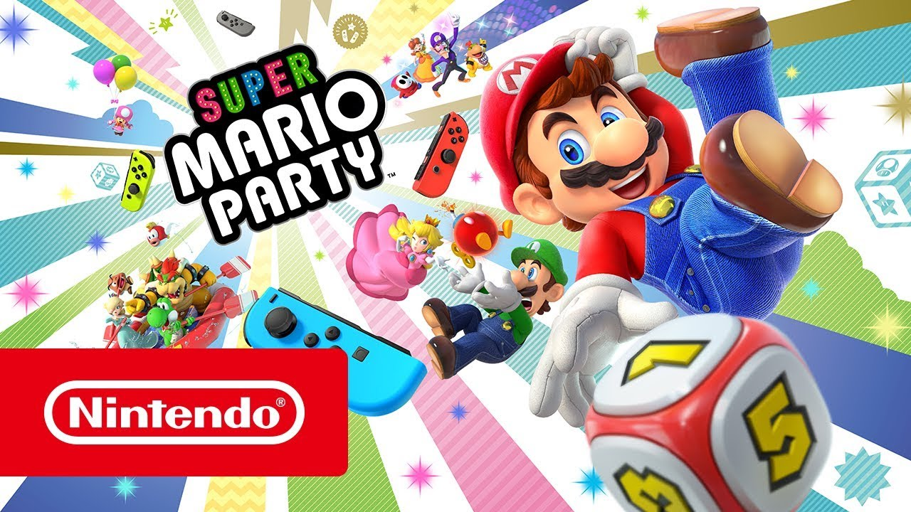
Developer: NDcube, Nintendo
Platform: Nintendo Switch
Genre: Party game, board game
Release Date: October 5, 2018
Sale Price: $59.99
Metacritic Rating: 76/100
Summary:
Mario party is a minigame filled, virtual board game that pits players against each other in pursuit of coins and stars.
Comparison:
Mario Party is a high profile Switch exclusive from Nintendo that is nearly a mainstay for every Switch owner. This game presents its content in a slightly different way than ours but the minigames could be considered a much smaller and less in depth version of our motion controlled gameplay. This poses a high threat because of its market penetration and control similarities.

Jackbox Party Pack 5 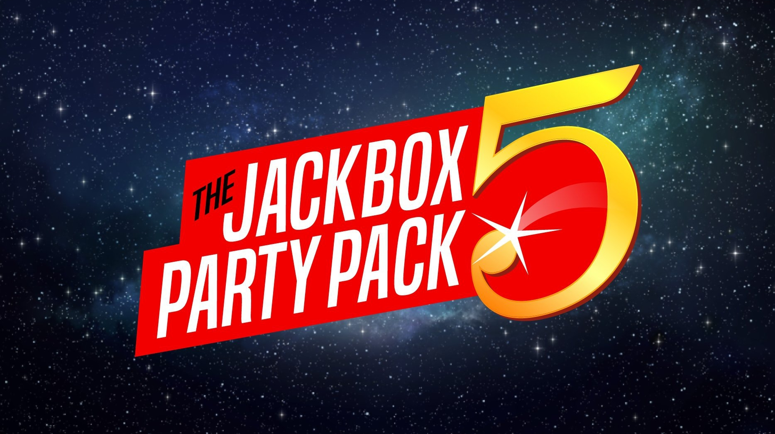
Developer: Jackbox Games
Platform: Mac, Windows, Linux, PS4, Xbox One, Switch, Apple TV, Amazon Fire TV, Android TV.
Genre: Party game
Release Date: October 17, 2018
Sale Price: 29.99
Metacritic Rating: 78/100
Summary:
“A variety of different games that might ask you to draw weird doodles, write the best inside joke, or answer hilarious trivia questions. There are hours of laughs in every pack!” - Jackbox Games
Comparison:
This is a very social party game with the ability to captivate many people. It is also well known but not nearly to the level of a mainstay. The threat from this game is purely from a party game perspective, being another option that consumers could opt for.

Overcooked 2

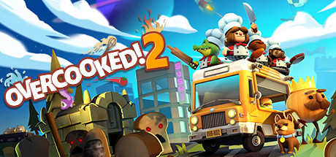
Developer: Ghost Town Games, Team 17 Digital Limited
Platform: Mac, Windows, Linux, PS4, Xbox One, Switch
Genre: Simulation, Couch Co-op
Release Date: August 7, 2018
Sale Price: $24.99
Metacritic Rating: 83/100
Summary:
“A chaotic co-op cooking game for 1-4 players in which you must serve a variety of recipes including sushi, pasta, cakes, burgers and burritos to hungry customers in a series of unconventional kitchens.” - Ghost Town Games
Comparison:
Overcooked 2 is also a kitchen/cooking simulator like Tilted, Not Stirred and has a positive reputation due to its predecessor, Overcooked. This game is a co-op game versus our competitive game which will lend a different atmosphere to the party. Because of this, Overcooked 2’s content poses a small threat but its stylistic properties differentiate it heavily from our game.

Mario Kart 8 Deluxe

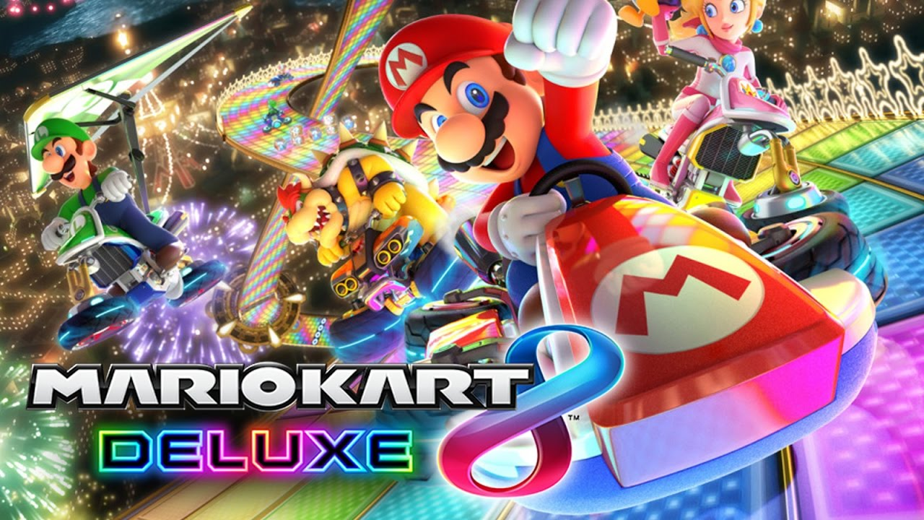
Developer: Nintendo
Platform: Nintendo Switch
Genre: Racing
Release Date: April 28, 2017
Sale Price: $59.99
Metacritic Rating: 92/100
Summary:
“Hit the road with the definitive version of Mario Kart 8 and play anytime, anywhere! Race your friends or battle them in a revised battle mode on new and returning battle courses.” - Nintendo
Comparison:
Mario Kart is a competitive party game that has fast paced action similar to what is found in our game. Obviously the content of racing vs bartending sets these games apart but the popularity and social aspects of the game make it a threat.

Cards Against Humanity

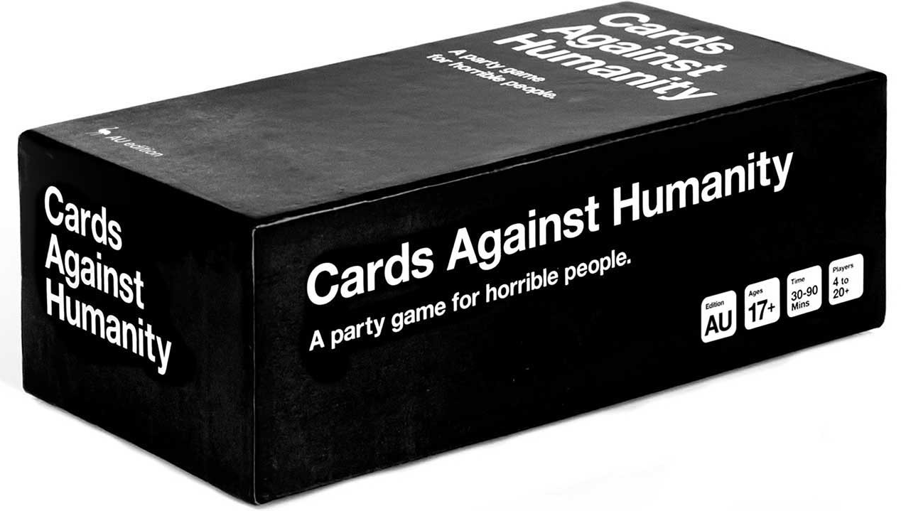
Developer: Cards Against Humanity
Platform: Physical
Genre: Party, Educational, Card Game
Release Date: May 2011
Sale Price: $25
BoardGameGeek Rating: 6/10
Summary:
“Cards Against Humanity is a party game for horrible people. The game is simple. Each round, one player asks a question from a Black Card, and everyone else answers with their funniest White Card.” - Cards Against Humanity
Comparison:
Cards Against Humanity positions itself as a threat to our game because of its strong social aspects and pre-existing integration into the party scene. While this game doesn’t compete with us directly on our delivery platform, some gamers may decide to play this instead of picking up a new game.

Exploding Kittens
Developer: The Oatmeal
Platform: Physical
Genre: Party, Card Game
Release Date: July 2015
Sale Price: $19.99
BoardGameGeek Rating: 5.9/10
Summary:
“Exploding Kittens is a highly strategic kitty-powered version of Russian Roulette. Players take turns drawing cards until someone draws an exploding kitten and loses the game.” - Exploding Kittens
Comparison:
This game competes with us from a social and strategic angle. Players playing both our game and Exploding Kittens will be looking for social interaction and mental fortitude. Exploding Kittens also moves at a slower pace than our game and will be a longer time investment.

Secret Hitler

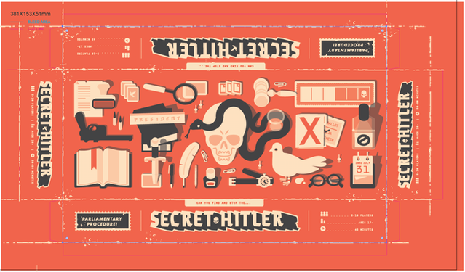
Developer: Secret Hitler
Platform: Physical
Genre: Party, Board Games
Release Date: August 25, 2016
Sale Price: $35
BoardGameGeek Rating: 7.6/10
Summary:
“Secret Hitler is a social deduction game for 5-10 people about finding and stopping the Secret Hitler.” - Secret Hitler
Comparison:
Secret Hitler is a much slower paced game than Tilted, Not Stirred. It involves more thinking and strategy while TNS requires quick mental agility and memory. This games theming also aligns more closely with ours than our other competitors and might attract a similar audience.

Swot Analysis

Strengths

Easily Expandable
The way that we have designed our levels and assets allow or us to rapidly expand the game after we have settled on our core game loop. For the additional levels we have a tool which the designers can use to quickly create a new level and add whichever steps are needed to complete that levels drinks. We also have every ingredient available in every level which cuts down on the amount of things that need to be added to each one. In fact, the only visual difference the player will be shown is the drink and recipe that are presented to them by the customer, all of the other differences are done in the backend. This would also translate to additional modes and continued support throughout the games life.

Distinctive Theming
Our games style and theme set it apart from other games and will be retained in the minds of our audience for multiple reasons. Black and white games, as well as spy games, are relatively few and far between in today's market; and when they do pop up they tend to be talked about quite a lot (think Hollow Knight). Both of these aspects will make our game stand out and stick in people's heads as a unique game that looks really cool. After that first exposure though art, our unique, elegant, frenetic, and spy based bartending simulation will stand out as something that people have never played before. All of this creates a unique atmosphere for our players within the game and outside of the game in their social gathering.

Quick Multiplayer Sessions
We have built our game model around having quick yet fulfilling and entertaining game sessions that people can play at a party and involve everyone there. The very first few levels are very easy so that people can learn the mechanics. As the difficulty scales into the later levels and more drinks are added we expect people to pick up the pouring pace and accelerate the time it takes them to make one drink. We will be combating this acceleration of game time with more drinks that are harder to make and spy gadgets that will make the game easier and harder to add variance to the game.

Weaknesses

Market Size
The market that we are targeting is somewhat specialized and won’t appeal 100% to the majority of gamers. It is a very socially driven game which is in contrast to a lot of the video game player base who are often introverted. In addition, our spy theming may turn away some players who are looking for a more boisterous drinking game to play with a high energy crowd. However, alcohol as a standard is popular with most people and that in combination with our quirky take on simulating bartenders will help attract people outside of our target market. Gamers inside our target market will love this game due to its social, alcoholic, and elegant elements.

Small Player Size
Currently this game is planned to only accommodate two players at a time. As a party game this detracts from its appeal to people who want to play this in medium to large group sizes. However, to combat this we have very short and socially interactable levels (as mentioned above) so that the audience can get involved both by playing a few rounds at a time and by backseat bartending.

Low Replayability
With the levels that we currently have planned the replayability and drive to perfect your skill in this game is somewhat lacking. Once the player has played the level once, they have experienced that drink and don’t feel a reason to make it again. To fix this, we want to implement much harder levels that will incorporate multiple drinks and a limited amount of strategy and physical skill that the player has to perfect to create their drinks to the customers satisfaction. We also want to include a level (drink) creator in the final product so that the game owner can create new drinks and levels for them and their friends to play through at their next gathering.

Opportunities

Popular Content
The content of our game is very popular with virtually everyone from and individual perspective. The spy portion will attract a lot of people, the alcoholic aspects will attract a lot of people, and the black and white aspect will attract a lot of indie folks who may not have been super interested by the other aspects. These initial “pop culture” aspects will attract quite a few people by themselves and then when they are combined and thrown into a social context they should strongly attract our target market.

Up-scale Alcohol Trend
In the past few years the popularity of liquor (spirits) and cocktails has risen in both the US and the UK (5). Both beer and wine are still more popular, but the attraction to beer has been waning quickly and the difference between the three categories is quite small when compared to other points in history. This upward trend of liquor consumption bodes well for our game which is based exclusively around the creation of cocktails.

Aging Gamers
Video games have been mainstream for roughly two decades depending on how you look at the market. This means that tennagers and young adults who have been playing games for many years and grew up playing very social gamers are now at the age where they can consume alcohol freely. This aging of the average gamer gives us more potential customers and stronger acceptance of this type of game into the gamer market.

Distribution System
Distributing our game on the Nintendo Switch automatically gives us a level of credibility that can only be provided by Nintendo. Nintendo has been a successful and well known developer and publisher for almost as long as the industry has been active. Being published on a semi-exclusive console owned by them tells our audience that this game has quality and backing without them having to even play or watch content about our it.

Threats

Stereotype Portrayal
Our game is trying to convey a slightly fancier or “higher class” feeling to our players, but we have to be careful that we don’t go too far in this direction. We don’t want to portray any stereotypes about the higher class that may be inaccurate or too specific, we are trying to stay very general and convey the feeling and not the specific representations of this class that is traditionally found in spy media and early modern cultures. We also want to be careful that we don’t imply anything about any other classes or groups of people as we try to represent specific types of drinks, characters, and branding that align with the higher classes. The higher class isn’t better, it’s simply our target market for this game.

Underage Alcohol Consumption
We have to keep in mind as we develop and market this game that one of the central themes in the game is alcohol, which is illegal for a large percentage of the market to consume. Buying our game doesn’t translate to drinking 1-1, but we do envision the consumption of alcohol accompanying the playing of this game a high percentage of the time it is played. This means that we have to be careful about how we market it and should avoid marketing it to underage gamers completely. We don’t need to have an age requirement on the purchase of the game, but we should not target and encourage underage drinkers to buy it due to high possibility that they will may consume alcohol while playing.

Distribution System
Developing for the Switch is at the core of our gameplay mechanics as well as boosting our games reputation. However, Nintendo has the right to decide who gets admitted to the eShop and can deny us access to a dev kit if they choose. This is a major threat to our game pre-launch that could shut us down or set us back a considerable amount of time. But, this is not an ongoing threat. Once we prove to Nintendo that we are indeed awesome than we won’t have any issues distributing our content.

Bibliography
1 World Atlas. “Who Drinks the Most Alcohol”, Sep 10, 2018
https://www.worldatlas.com/articles/who-drinks-the-most-alcohol-consumption-by-country.html
2 Wilsnack, Wilsnack, Kristjanson, Vogeltanz-Holm, Gmel,. “Gender and Alcohol
Consumption: Patterns from the Multinational Genacis Project”, PMC, Sep 1, 2010
https://www.ncbi.nlm.nih.gov/pmc/articles/PMC2844334/
3 Pew Research Center. “Social Media Use in 2018”, Mar 1, 2018
https://www.pewinternet.org/2018/03/01/social-media-use-in-2018/
4 YouGov. “The Most Popular Social Networks in the UK”,
https://yougov.co.uk/ratings/technology/popularity/social-networks/all
5 Ritchie, Rosner. “Alcohol Consumption”, Our World in Data.
https://ourworldindata.org/alcohol-consumption
6 Nintendo. “eShop”, 4/11/19
https://www.nintendo.com/games/game-guide/#filter/:q=&dFR[availability][0]=Available%20now&dFR[categories][0]=Party&dFR[platform][0]=Nintendo%20Switch

